DEPARTMENT OF COMPUTER ENGINEERING AND TECHNOLOGY

**BTech Capstone Project Academic Year 2024-2025**

**Title of Project: Fake News Detection with Dynamic Model Updates Based on Classifier Comparison**

**Name of Students: Maitreyee Jadhav, Mansi Patil, Preshika Giri, Vinay More**

**Group ID: SP37**

**Name of Internal Guide: Dr Yogita Hande**

**Summary of Work:**

**Abstract:** Our project introduces a machine learning-based system for fake news detection by analyzing textual content. Preprocessing

techniques like tokenization, stopword removal, and stemming are applied, followed by feature extraction using TF-IDF and Countvectorizer.

Models including SVM, Logistic Regression, and Naive Bayes are trained and evaluated. SVM outperforms others and is selected for deployment.

A dynamic updating strategy ensures the model adapts to evolving patterns in misinformation over time.

**Objectives:** This project aims to build a dynamic fake news detection system by comparing machine learning models to identify the most accurate one, enabling periodic updates with new data to improve performance and adapt to evolving misinformation.

**Methodology:**

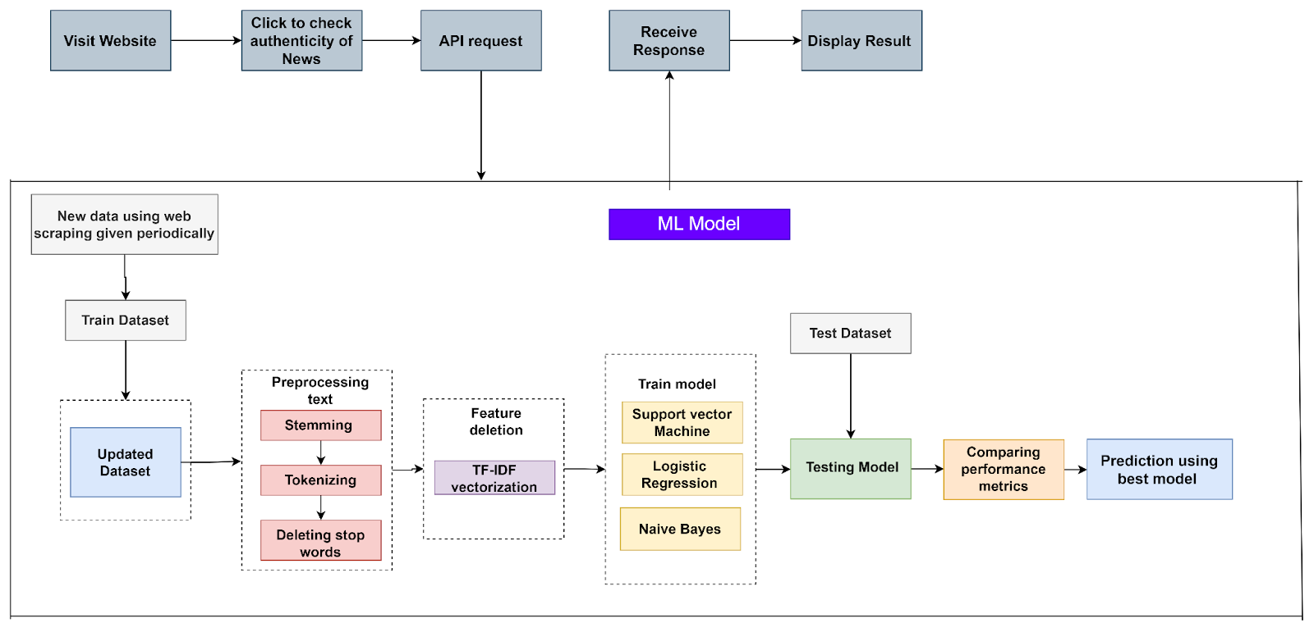

**Result Analysis:**

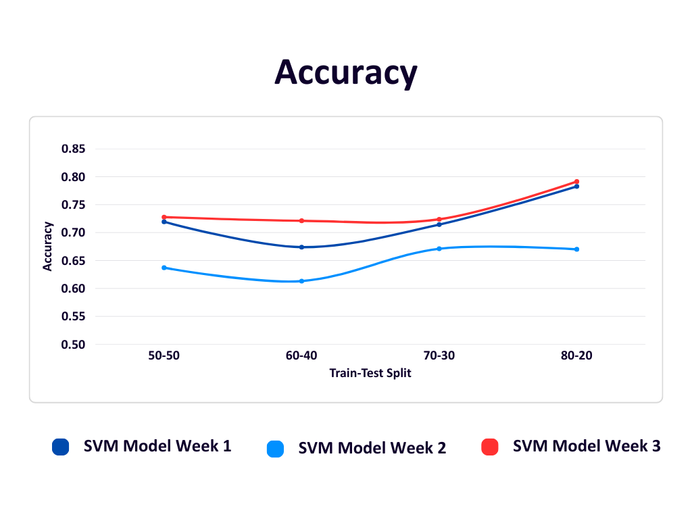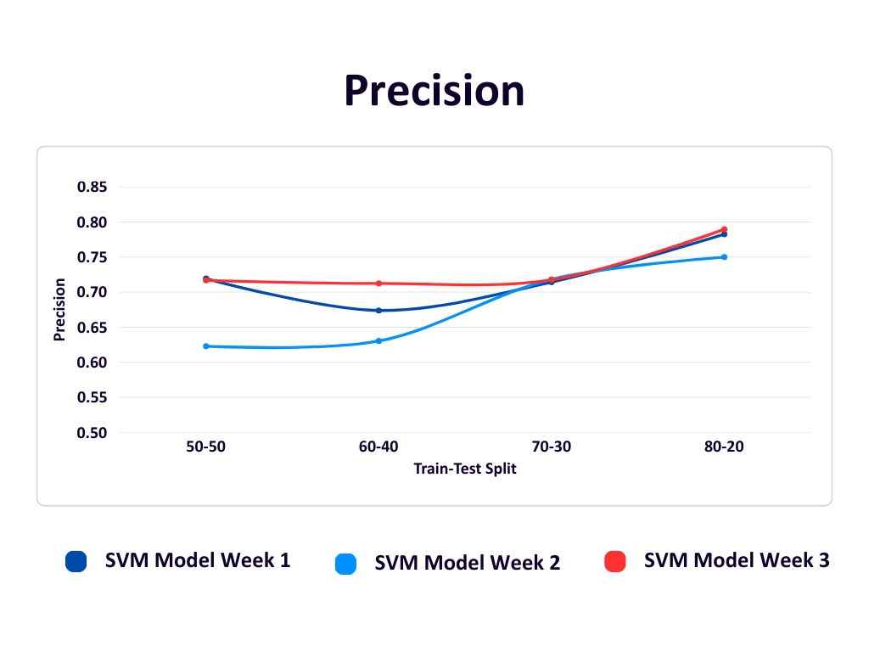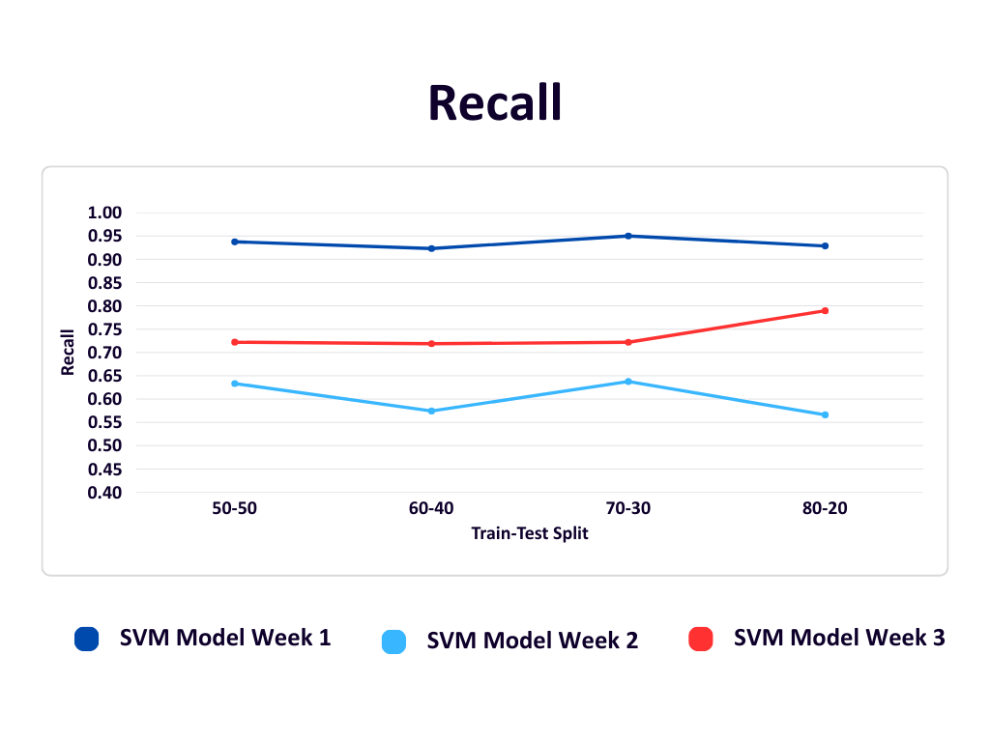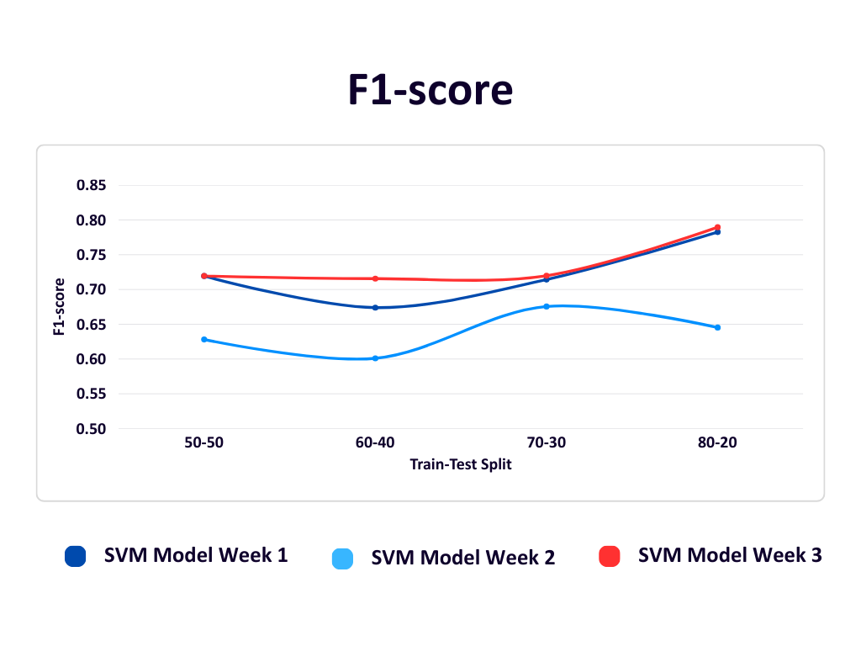

It is observed that SVM performs better compared to LR and NB so it is selected as the final model. The accuracy, precision, recall and f1

score in week 3 were, 0.7913, 0.7895, 0.7895 and 0.7895, respectively, for 80-20 train-test split.

**Conclusion:** Our project develops a machine learning system for fake news detection, comparing SVM, Logistic Regression, and Naive Bayes.

SVM outperformed the others, offering accuracy and adaptability. The system supports dynamic updates and sets the foundation for future

improvements like deep learning and real-time detection.